PRE TRAVEL RISK ASSESSMENT FORM

If you plan to travel, please complete our pre travel assessment form at least 6 weeks before your travel date and return it to the Practice.
You will be contacted if an NHS prescription is required and has been issued, please allow a minimum of 5 working days for this. Ensure the surgery has an up to date contact phone number for you. Please remember to book a treatment room appointment for the administration of your vaccines if required.
Travel information will also be attached to your prescription and will indicate recommended or optional vaccinations which are private (not covered on NHS). The surgery does not provide private travel clinic services, so if you feel you need any of these vaccinations, please attend a Private Travel Clinic.
Travel Vaccines available on the NHS:
Hepatitis A, Typhoid, Tetanus, Diptheria, Polio, Cholera
Private Travel Vaccinations (NOT covered by the NHS and NOT provided by the Practice):
Hepatitis B, Meningitis ACWY, Rabies, Yellow Fever, Japanese Encephalitis, Tick Borne Encephalitis
If you are travelling to an area where Malaria is present, this will also be indicated on your information and you will be signposted to a community pharmacy to purchase the medication required over the counter. The Surgery does not provide anti malaria tablets.

PLEASE NOTE:

If you are travelling in less than 6 weeks time, unfortunately this is not sufficient time to allow for an NHS vaccine risk assessment, generation of prescriptions and administration of vaccines. Under these circumstances you MUST attend a Private Travel Clinic to source all of your vaccinations prior to travel.

Ormeau Health Centre

Pre Travel Risk Assessment Form

Name:

Date of Birth: | Male/Female
Date of travel:
Date of return:

Destination: Give details of the countries you will be visiting, in the correct order, including any countries you may be just passing through.

Country to be visited  Area/Region | Length of stay | Type of  accommodation | Travelling to remote areas or away from medical help?
1.
2.
3.
4.
5.
6.
7.
8.

Type of travel: Circle which activity best describes the purpose of your trip
Reason for travel | Business Pleasure Other
Type of holiday/travel | Package Cruising Trekking  Self organised Camping Backpacking
Are you travelling with? | Family Group Alone
Planned Activities | Leisure Adventure Safari

Personal Medical History:

Give details of any conditions which may affect your travel plans

Do you have any current or past medical conditions of any note e.g.
pregnancy, diabetes, heart or lung conditions, epilepsy, thymus disorders, cancer, HIV?
List any medication that you are taking

Do you have or have you ever had any of the following:

Allergies (e.g. eggs, antibiotics)
A previous reaction to any vaccine
Recent surgery
Treatment with steroids, chemotherapy or radiotherapy
High blood pressure
Epilepsy
Fainting
Anxiety, depression or mental illness

Vaccination history:

Please tick any travel vaccine that you have previously been given, stating when.
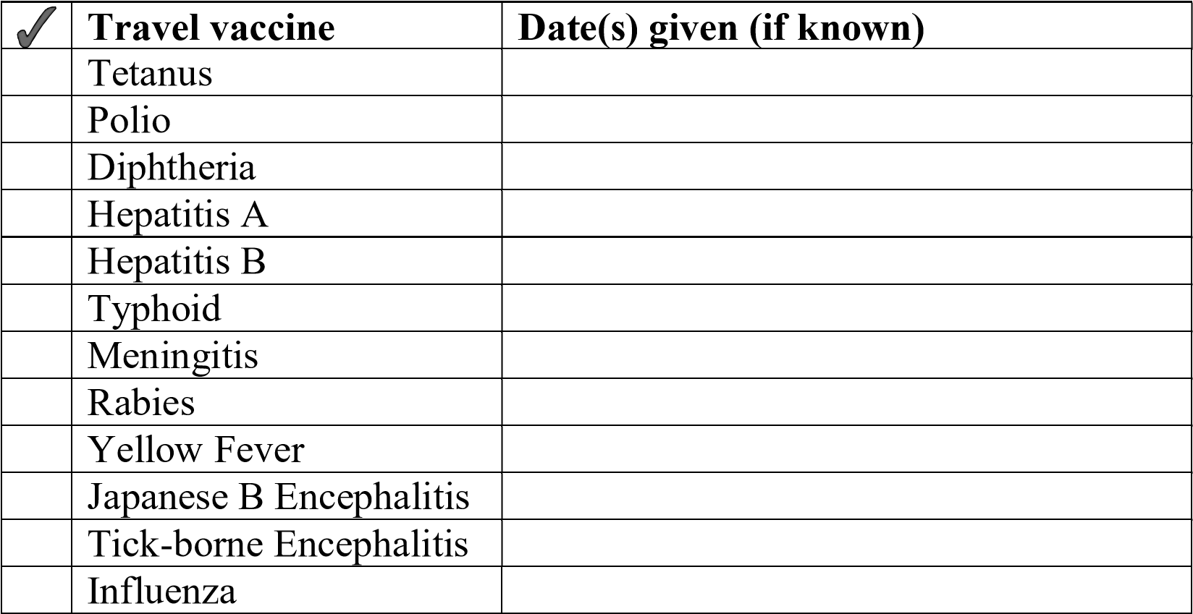

Please detail below any further information that you may fell might be relevant:

I am aware that if I wish to receive vaccinations for Hepatitis B, Meningitis ACWY, Yellow Fever, Japanese Encephalitis, tick borne encephalitis or Rabies I must source these privately through a private travel clinic

I am aware that if I am travelling to an area where Malaria is present it is my responsibility to source the anti-malaria tablets from a community pharmacy or private travel clinic.

Signed: ______________________ Date: _____________

